**Continue building the big data analysis solution by applying advanced analysis techniques and results.**

**Step 1: Open the IBM cloud .**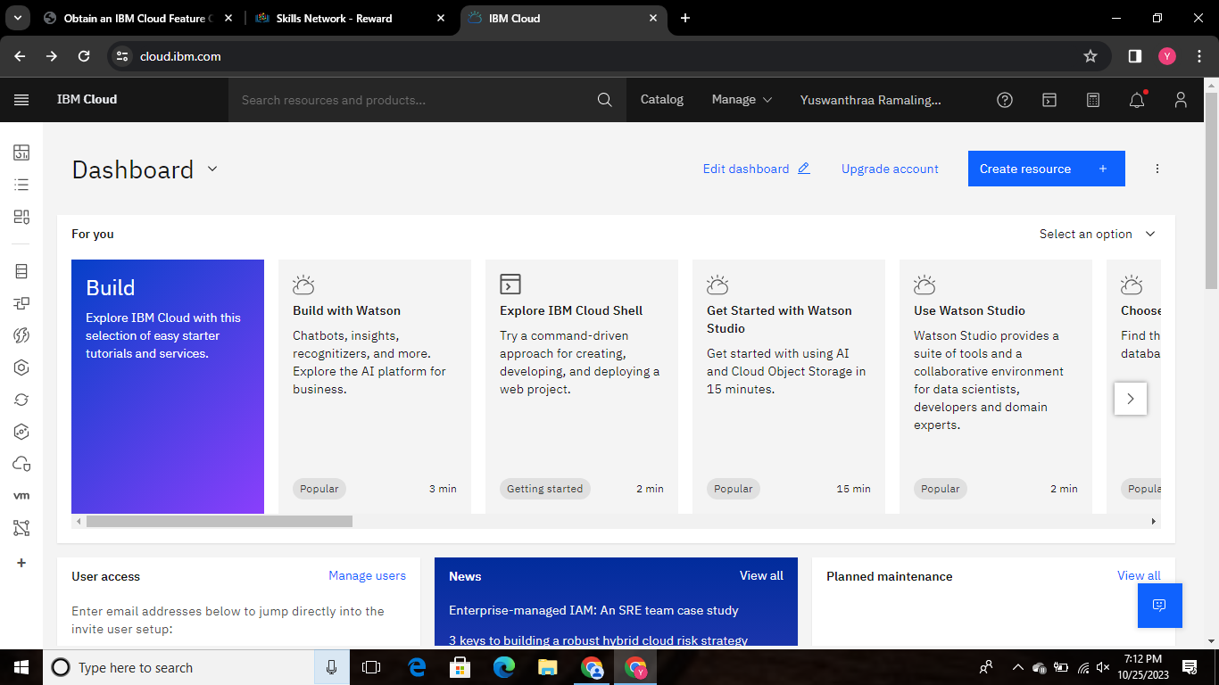

**STEP 2 : Click it (browse the service) then the catalog page will open here . In this catalog we need to choose the storage for object storage.**

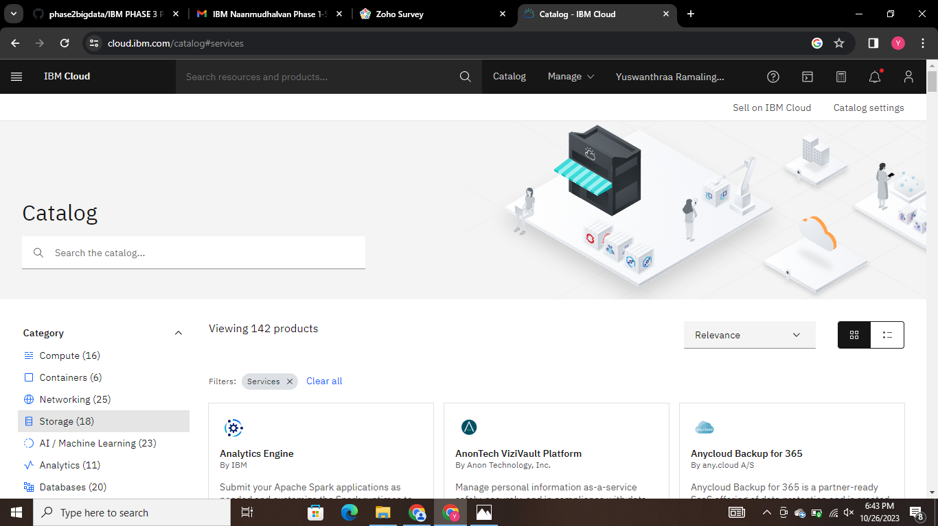

**In this catalog click the storage to open the object storage to create a bucket.**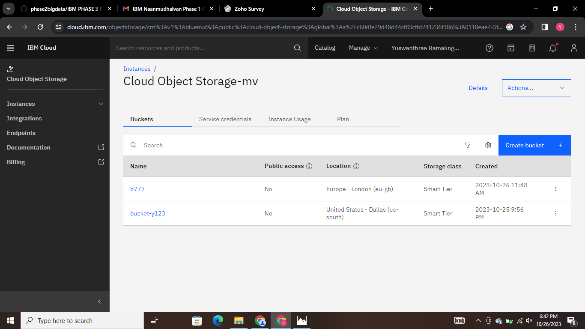

**How many buckets we need we can create it. So, i where created a two buckets.**

**STEP 3 : In this step we can see how to create a bucket in cloud object storage.**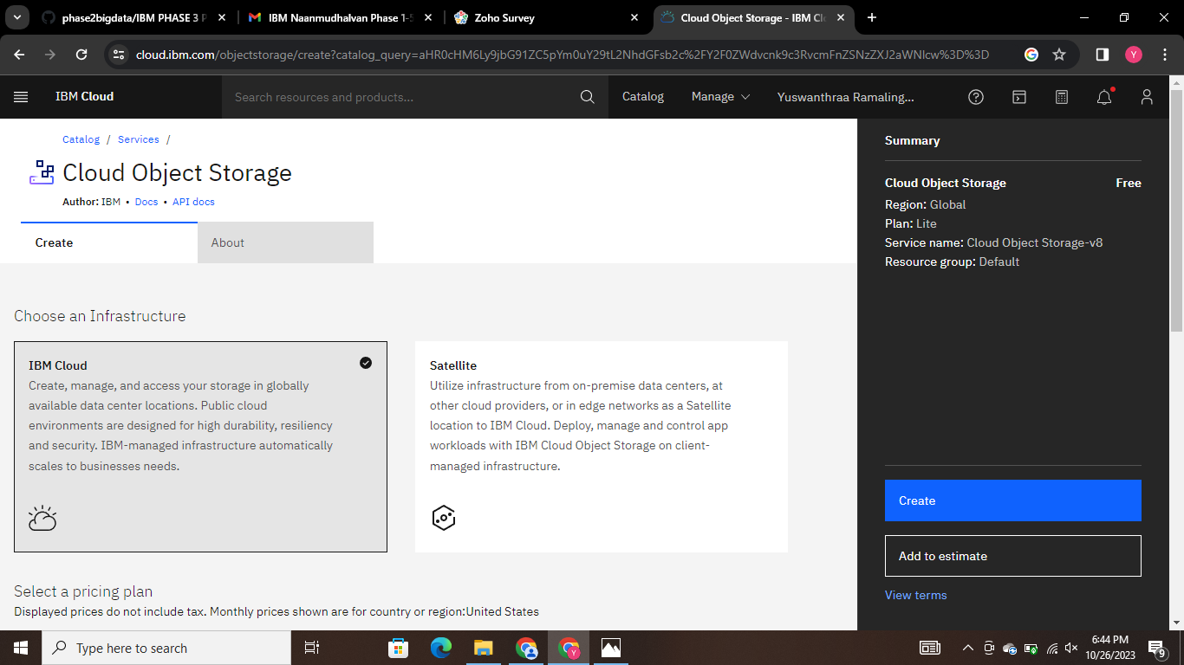

**In this cloud object storage first of all we need to click the IBM cloud box, and click the lite pricing then change the location in Europe (London eu-bg) . To create a bucket, first need to give the unique name and change the location then click the create button.** 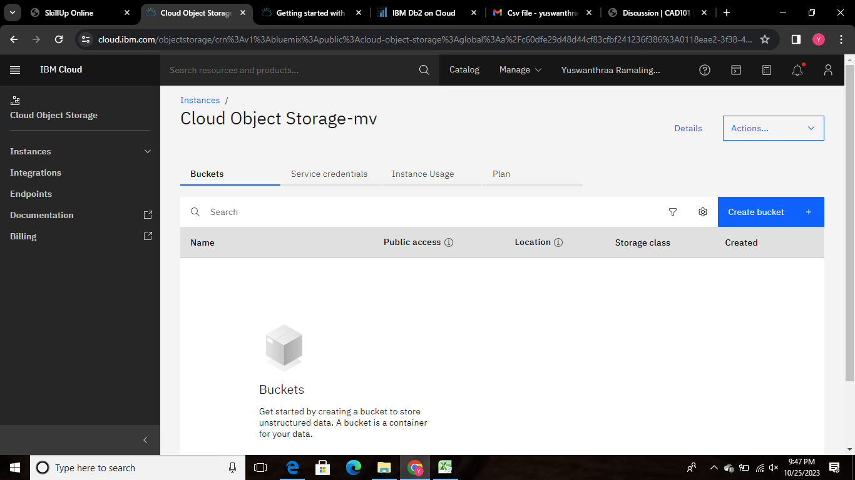 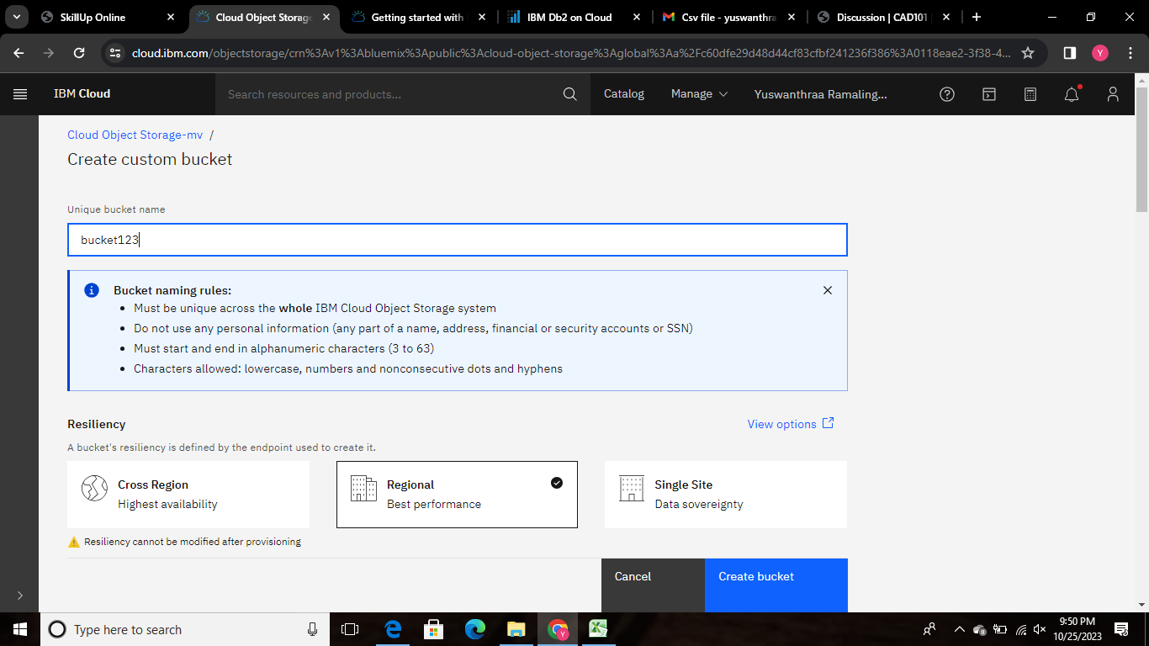

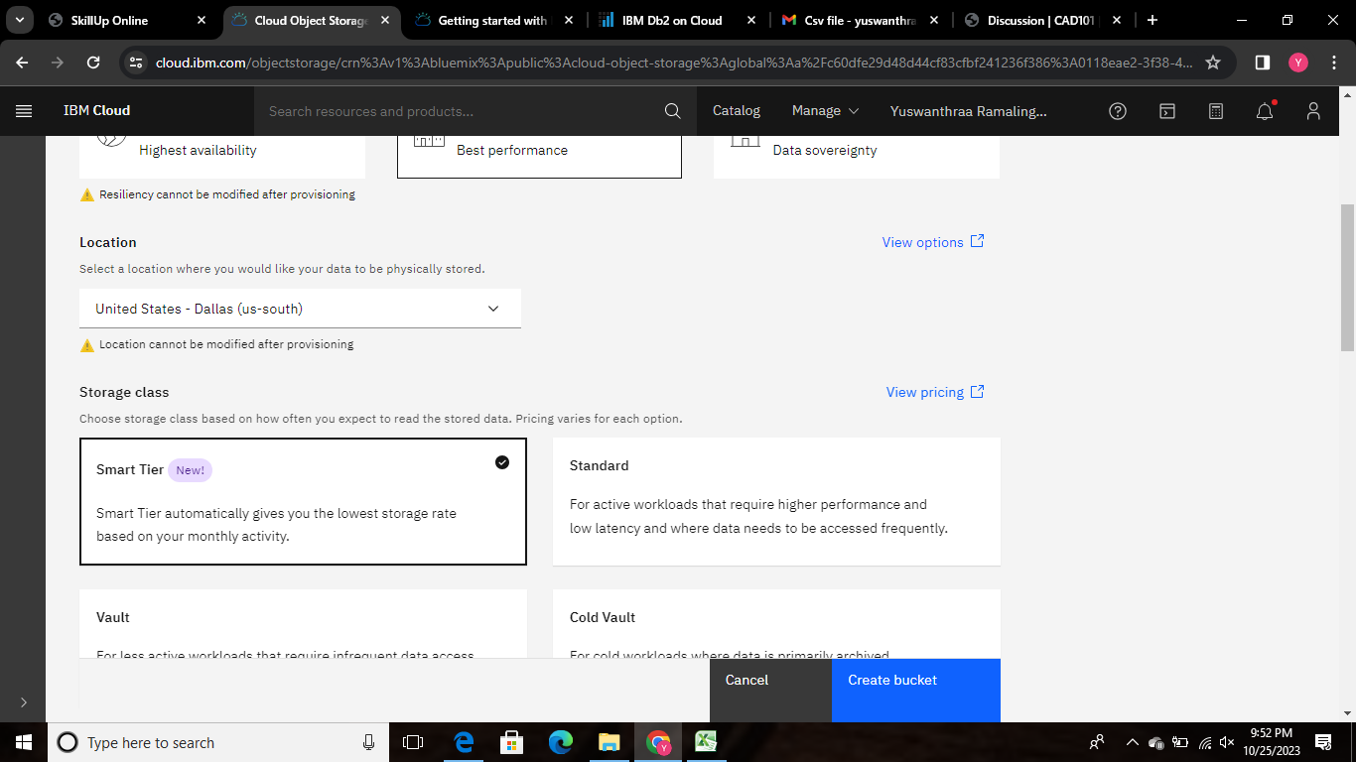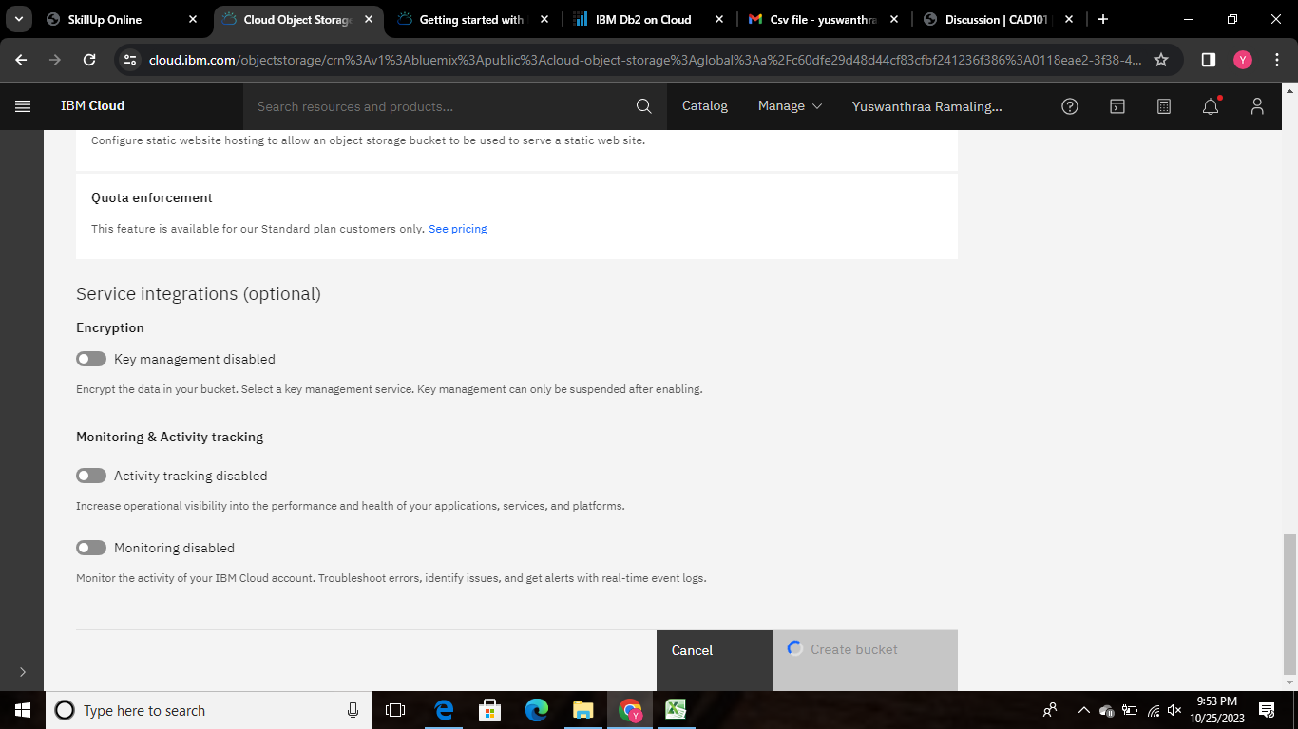

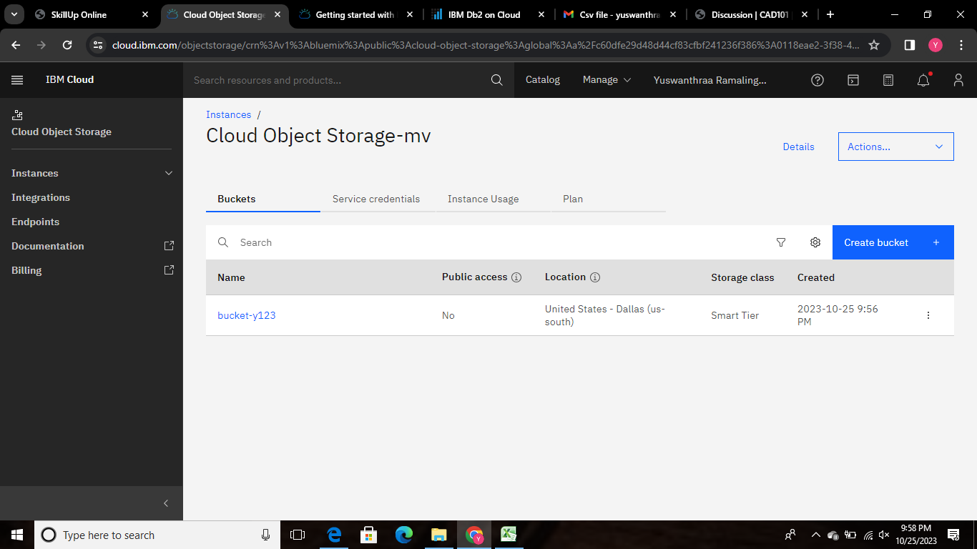

**Successfully we created a bucket. Click the created bucket file to open the file and click the object name for uploading the dataset then we get a message from upload information.**

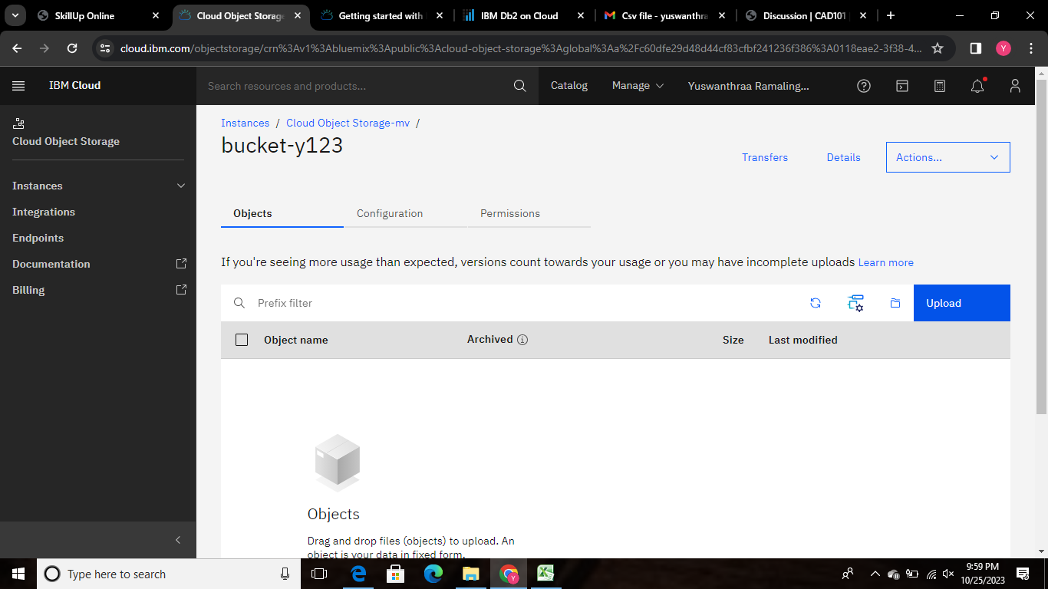

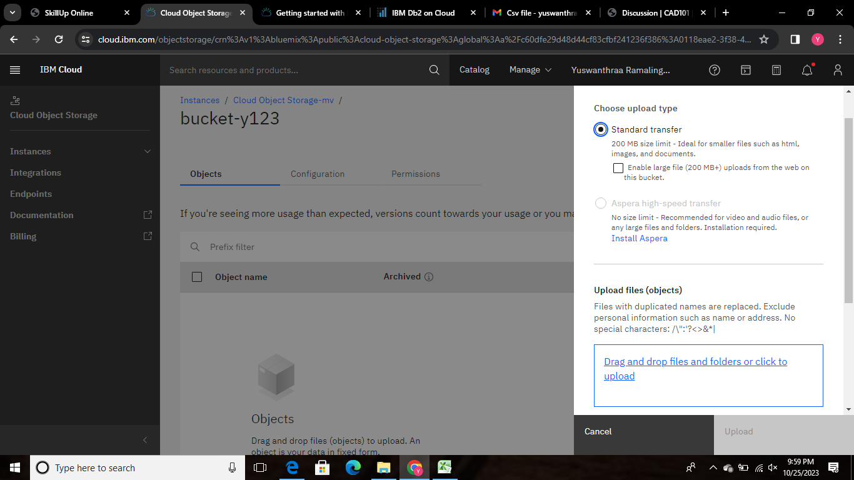

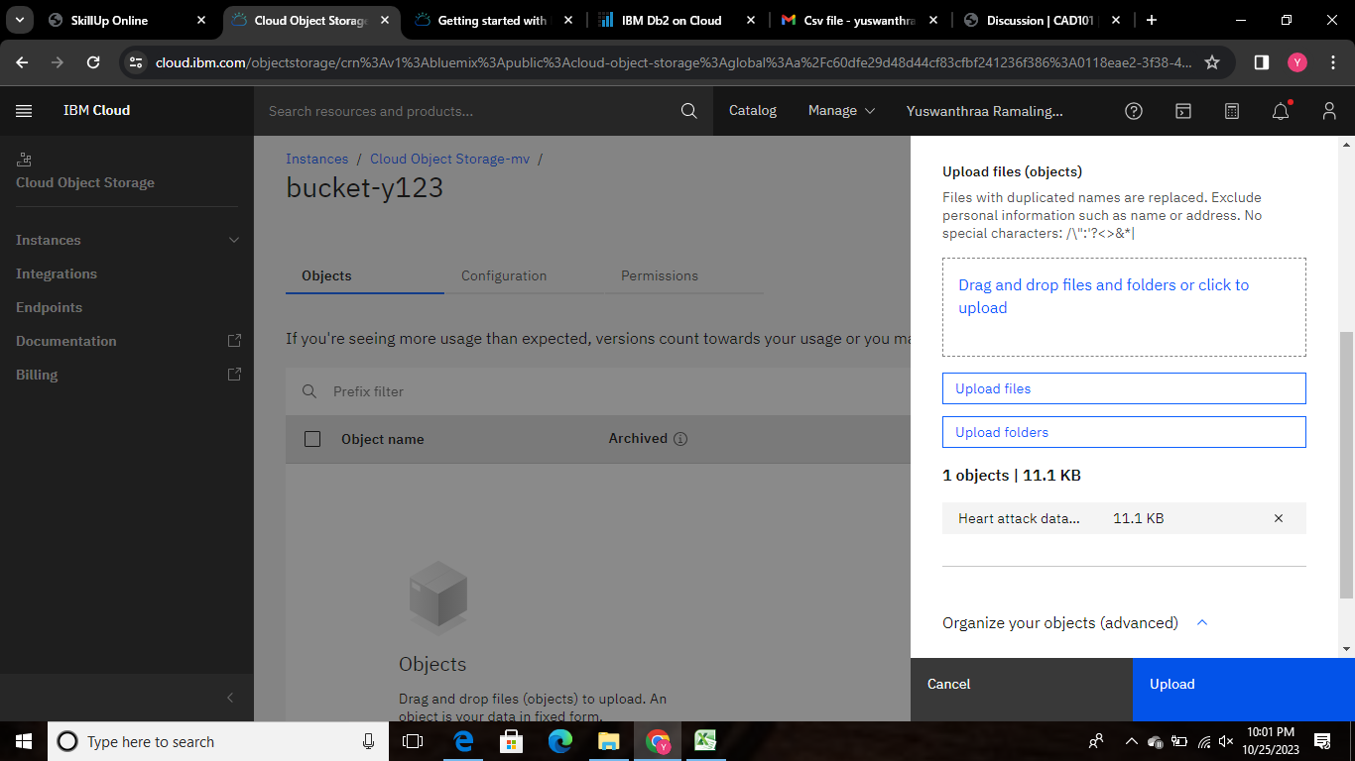

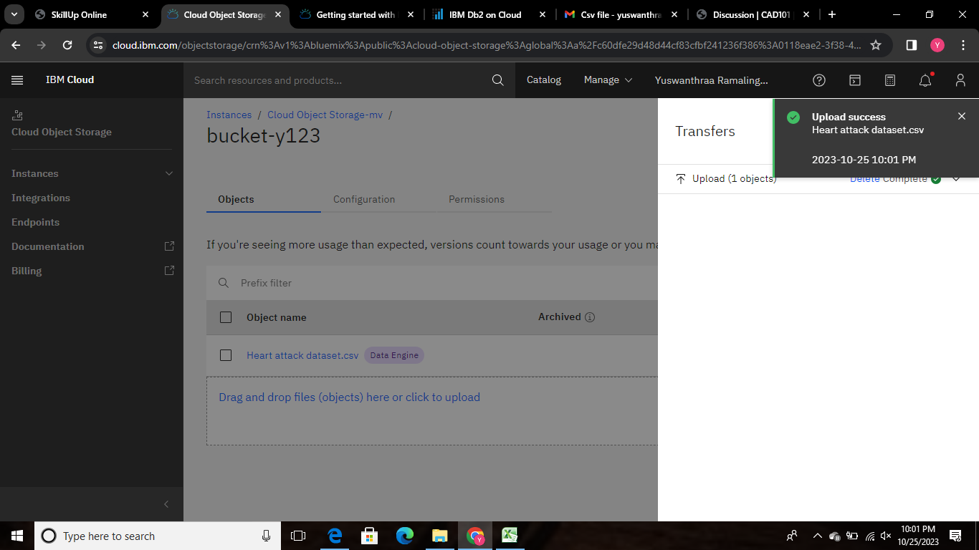

**Successfully completed to upload the dataset to visualize in a advanced techniques.**